*Data warehouse loading*

final project

Version *2.0*

*PM600*

*Instructor: Richard Dunham*

*09/10/2019*

*Group 2:*

*Mukesh Kavadapu*

*Shahnoor Tariq*

*Undrakh Sasrantsetseg*

*Xi Zhang*

VERSION HISTORY

|  |  |  |  |  |  |
| --- | --- | --- | --- | --- | --- |
| **Version #** | **Implemented**  **By** | **Revision**  **Date** | **Approved**  **By** | **Approval**  **Date** | **Reason** |
| 1.0 | Group 2 Project Team | 08/15/2019 | CFO | 08/16/2019 | Original Document |
| 2.0 | Group 2 Project Team | 09/10/2019 | CEO | 09/11/2019 | Final Version |
|  |  |  |  |  |  |
|  |  |  |  |  |  |

TABLE OF CONTENTS

1 INtroduction 3

2 Project Charter 3

2.1 Project Objectives 3

2.2 Overview of Deliverables (requirements): 6

2.3 Key Assumptions: 6

2.4 High Level Risks: 7

2.5 Key Milestones: 7

2.6 Budget: 8

2.7 Primary Stakeholders and Roles: 8

3 Work Breakdown Structure & Project Schedule 10

4 project budget 16

5 communication plan 16

6 Risk register 18

7 group lessons learned 19

8 References 20

# 

# 1 INtroduction

The intended audience of the Data Warehouse Loading is all project stakeholders including the project sponsor, senior leadership and the project team.

Construct a Microsoft SQL Server 2017 data warehouse and create software to populate the data warehouse from provided ACIS and PAC text file extracts. C&Z researchers will access the data warehouse with their existing data analysis software.

C&Z researchers will also be able to push the analyzed data sets back into the data warehouse for other researchers to use.

IT department of ABC Connect will create an application to load the 20 different ACIS text file types and a variety of PAC text file types. The application will provide a mechanism to map the imported text data to specific fields in Microsoft SQL Server tables. The resulting 20 ACIS SQL Server tables and assorted PAC SQL Server tables will be referred to as the “raw data” tables. Business team defined rules will be checked during the loading process for each table to determine if the incoming record is a new record or an update to an existing record. If the incoming data already resides in the raw table then that existing record is marked inactive and the incoming record becomes the active record. This provides a way to maintain a history of all data that has been loaded in case a review of prior loaded records needs to be completed.

Project team (PT) will create a process within SQL Server to join, link and process active records from the external raw data tables into a single data warehouse table.

This process will delete and then re-create the single data warehouse file from the raw data files. Researchers will access the data warehouse with their existing data analysis software. The new software created by PT will provide the ability to push data from external storage to SQL Server tables for other C&Z researches to use in further analysis.

# Project Charter

***Worksheet: The Project Charter***

**Project Name: Data Warehouse Loading**

**Project Managers: Mukesh Kavadapu, Shahnoor Tariq, Undrakh Sasrantsetseg, Xi Zhang**

**Date: 07/21/2019**

## Project Objectives

The C&Z Tech Inc. has implemented a Compliance Data Warehouse (DW) to enhance the ability to identify and collect invoiced shipped and unshipped products from their warehouse with 2 times. There are two major thrusts to this effort: 1) improving audit selection, and 2) implementing tape match programs. Both require the loading of internal and external data sources. The focus of the Data Warehouse Data Loading project is to load new external data sources into the DW to enhance efficiency with 2 times by both improving existing compliance projects and initiating new efforts, thus improving compliance and bringing in additional revenue. The project will cost $750k.

Existing capabilities and project complexity will increase by loading additional external data sources. Additional functionality will include:

§ Producing higher quality results

§ Identifying warehouse parts on time requirements

§ Reducing false positive assessments to <5%

§ Improving research collectability with 2 times

§ Decrease processing 50% times through acquisition of additional resources (hardware/software)

|  |  |
| --- | --- |
| PROJECT CHARTER | DESCRIPTION |
| Project Name: | Data Warehouse Loading |
| Project Sponsor: | ABC Investment Ltd. |
| Project Manager: | Mukesh Reddy Kavadapu |
| Email Address: | Mukeshreddyk95@gmail.com |
| Phone Number: | 7204046064 |
| Expected Start Date: | 08/19/2019 |
| Expected Completion Date: | 09/24/2019 |
| Problem or Issue: | What data management technology/How much disk space/What is the process to get business requirement |
| Purpose of Project: | Reduce 50% Business Intelligence cost |
| Expected Deliverables | * Modify and update Planning Documents as the project team learns more about the project brings on support vendors and responds to changing or evolving conditions.      * Recruit and hire project labor resources to include a Project Manager and service vendor.      * Develop Data Source Load and Validation Requirements.      * Load External Data Sources in Development Environment.      * Unit and system test External Data Sources in Development Environment.      * Configure Project in Development Environment.      * Documentation and Knowledge Transfer. |
| Project Team: | C&Z Project Team |
| Support Resources: | C&Z Inc. |
| Special Needs: | N/A |
| Key Stakeholders: | Meshal Alquraishi , Shah Noor Tariq,Undrakh Sarantetseg,  Bill Walker, Joe Johnson |
| Final Customers: | C&Z Tech Inc. |
| Expected Benefits: | Enhance the ability to identify and collect invoiced shipped and unshipped products from their warehouse with 2 times. |
| Risks: | Loss of project sponsor/ changing requirements/ Resource availability/ Availability of data sources |

## Overview of Deliverables (requirements):

· Modify and update Planning Documents as the project team learns more about the project brings on support vendors and responds to changing or evolving conditions.

· Recruit and hire project labor resources to include a Project Manager and service vendor.

· Develop Data Source Load and Validation Requirements.

· Load External Data Sources in Development Environment.

· Unit and system test External Data Sources in Development Environment.

· Configure Project in Development Environment.

· Documentation and Knowledge Transfer.

## Key Assumptions:

· Business subject experts will be available when needed for the implementation of the project.

· Technical IT resources from company will be available for the transfer of knowledge during the implementation.

· Company is responsible for purchasing hardware and software required for implementation.

## High Level Risks:

. Stakeholder requirements are not satisfied

. Loss of project sponsor

. Changing requirements

. Resource availability

. Availability of data sources

## Key Milestones:

. Completing the project on time

. Planning, design, implementation and testing should be done within the budget.

1. Requirements gathering & Certifications 8/19/2019 – 8/23/2019

2. Acquisition 8/21/2019 – 8/22/2019

3. Load data source 8/23/2019 – 8/27/2019

4. Inventory 8/27/2019 – 8/29/2019

5. Application development 8/29/2019 – 9/11/2019

6. Testing 9/12/2019 – 9/16/2019

7. Documents 8/19/2019 – 9/20/2019

8. Closing 9/19/2019 – 9/24/2019

## Budget:

|  |  |  |
| --- | --- | --- |
| **Identifier** | **Work Package or Budget Category** | **Cost** |
| 1 | Consulting Services | $350,000 |
| 2 | Hardware | $75,000 |
| 3 | Software | $75,000 |
| 4 | Staffing | $250,000 |
| **TOTALS** |  | $750,000 |

## Primary Stakeholders and Roles:

C&Z Inc. - Customers (Who bear financial and operational risks associated with a firm’s performance)

ABC Investment Ltd. - Sponsor (Covers the financial and organizational responsibilities and activities that are directed to quick and decisive governance of the project.)

ABC Connect – Technical Vendor (Conduct all the technical job related to Data Warehouse Loading project.)

Mukesh Reddy - Project Coordinator (Maintaining and monitoring project plans, project schedules, work hours, budgets and expenditures. )

Shah Noor Tariq - Project Coordinator (Maintaining and monitoring project plans, project schedules, work hours, budgets and expenditures.)

Undrakh Sarantetseg - Project Coordinator (Maintaining and monitoring project plans, project schedules, work hours, budgets and expenditures. )

Bill Walker - CEO of C&Z Inc.

Joe Johnson – CIO of C&Z Inc.

**Signatures**—

The following signature designates ___Mukesh Reddy_________ as the project manager, and authorizes him/her to draw funds to plan and execute this project.

* Project sponsor and/or authorizing manager(s):

Meshal Alquraishi Shah Noor Tariq Undrakh Sarantetseg

Counter signatures:

Project Managers: _____Xi Zhang________________

____Mukesh Alquraishi_________

____Shah Noor Tariq___________

____ Undrakh Sarantetseg ______

Agree to accept responsibility for the successful planning, execution and close-out of this project.

# Work Breakdown Structure & Project Schedule

|  |  |  |  |  |  |
| --- | --- | --- | --- | --- | --- |
| WBS | Task Name | Duration | Start | Finish | Resource Names |
| **1** | **Data Warehouse Loading** | **27 days?** | **Mon 8/19/19** | **Tue 9/24/19** |  |
| **1.1** | **Requirements** | **4.25 days** | **Mon 8/19/19** | **Fri 8/23/19** |  |
| **1.1.1** | **Define technical requirements** | **2.25 days** | **Mon 8/19/19** | **Wed 8/21/19** |  |
| 1.1.1.1 | Contact vendor | 1 day | Mon 8/19/19 | Mon 8/19/19 |  |
| 1.1.1.2 | Prepare hardware | 1 day | Tue 8/20/19 | Tue 8/20/19 | Office Supply[8 Unit],Project Manager |
| 1.1.1.3 | Request license | 2 hrs | Wed 8/21/19 | Wed 8/21/19 | License[$8,000.00] |
| 1.1.1.4 | Acquire data for data loads | 4 hrs | Mon 8/19/19 | Mon 8/19/19 |  |
| **1.1.2** | **Define staffing requirements** | **1.25 days** | **Mon 8/19/19** | **Tue 8/20/19** |  |
| 1.1.2.1 | Identify DW resources | 2 hrs | Tue 8/20/19 | Tue 8/20/19 | Database Developer |
| 1.1.2.2 | Identify vendor resources | 2 hrs | Tue 8/20/19 | Tue 8/20/19 | Sales Representitive |
| 1.1.2.3 | Identify IT department | 0.5 days | Mon 8/19/19 | Mon 8/19/19 |  |
| **1.1.3** | **Define business requirements** | **1 day** | **Wed 8/21/19** | **Wed 8/21/19** |  |
| 1.1.3.1 | Write data loads requirements | 0.25 days | Wed 8/21/19 | Wed 8/21/19 | Database Developer |
| 1.1.3.2 | Write business rules | 1 day | Wed 8/21/19 | Wed 8/21/19 | Project Manager |
| **1.2** | **Acquisition** | **2 days** | **Wed 8/21/19** | **Thu 8/22/19** |  |
| **1.2.1** | **Purchase hardware** | **1 day** | **Thu 8/22/19** | **Thu 8/22/19** |  |
| 1.2.1.1 | Select vendor | 1 day | Thu 8/22/19 | Thu 8/22/19 | Hardware[$12,000.00] |
| **1.2.2** | **Purchase software** | **2 days** | **Wed 8/21/19** | **Thu 8/22/19** |  |
| 1.2.2.1 | Select vendor | 1 day | Wed 8/21/19 | Wed 8/21/19 | Software[$16,000.00] |
| **1.3** | **Implementation** | **2.5 days** | **Fri 8/23/19** | **Tue 8/27/19** |  |
| 1.3.1 | Insatall hardware | 0.5 days | Fri 8/23/19 | Fri 8/23/19 | Labor,Subcontractor |
| **1.3.2** | **Install software** | **2.5 days** | **Fri 8/23/19** | **Tue 8/27/19** |  |
| 1.3.2.1 | Install operating system | 1 day | Fri 8/23/19 | Mon 8/26/19 | DBA |
| 1.3.2.2 | Install database | 1 day | Mon 8/26/19 | Tue 8/27/19 | DBA |
| 1.3.2.3 | Install applications | 1 day | Mon 8/26/19 | Tue 8/27/19 | Database Developer |
| 1.3.2.4 | Configure redundancy | 0.5 days | Fri 8/23/19 | Fri 8/23/19 | Database Developer |
| **1.4** | **Inventory** | **3 days** | **Tue 8/27/19** | **Thu 8/29/19** |  |
| **1.4.1** | **Load data** | **2 days** | **Tue 8/27/19** | **Wed 8/28/19** |  |
| 1.4.1.1 | Process data loading from external source | 2 days | Tue 8/27/19 | Wed 8/28/19 | Database Developer |
| **1.5** | **Application development** | **10 days** | **Thu 8/29/19** | **Wed 9/11/19** |  |
| **1.5.1** | **Develop application code for integration** | **5 days** | **Thu 8/29/19** | **Wed 9/4/19** |  |
| 1.5.1.1 | Develop coding for systems integration | 5 days | Thu 8/29/19 | Wed 9/4/19 | Database Developer |
| 1.5.1.2 | Troubleshooting and debugging | 1 day | Wed 9/4/19 | Wed 9/4/19 | Software |
| 1.5.1.3 | Monitoring | 5 days | Thu 8/29/19 | Wed 9/4/19 | Software |
| 1.5.1.4 | Updates application | 1 day | Wed 9/4/19 | Wed 9/4/19 | Software |
| 1.5.1.5 | Security | 1 day | Wed 9/4/19 | Wed 9/4/19 | Software |
| **1.5.2** | **Configuration** | **1 day** | **Thu 9/5/19** | **Thu 9/5/19** |  |
| 1.5.2.1 | Configure systems | 1 day | Thu 9/5/19 | Thu 9/5/19 | Database Developer |
| **1.5.3** | **Testing** | **4 days** | **Fri 9/6/19** | **Wed 9/11/19** |  |
| 1.5.3.1 | Initial test and send to operation team | 4 days | Fri 9/6/19 | Wed 9/11/19 | Database Developer |
| 1.5.3.2 | Test strategy according to the scope | 1 day | Fri 9/6/19 | Fri 9/6/19 |  |
| 1.5.3.3 | Estimate the test effort and team | 1 day | Fri 9/6/19 | Fri 9/6/19 |  |
| 1.5.3.4 | Define test schedule | 1 day | Mon 9/9/19 | Mon 9/9/19 |  |
| **1.6** | **Implementation testing** | **3 days** | **Thu 9/12/19** | **Mon 9/16/19** |  |
| **1.6.1** | **Test hardware and software** | **3 days** | **Thu 9/12/19** | **Mon 9/16/19** |  |
| 1.6.1.1 | Require tools needed for testing and management | 1 day | Thu 9/12/19 | Thu 9/12/19 | Sales Representitive,Software |
| 1.6.1.2 | Develop Test Plan | 1 day | Thu 9/12/19 | Thu 9/12/19 | DBA |
| 1.6.1.3 | Conduct User Acceptance Testing | 1 day | Fri 9/13/19 | Fri 9/13/19 | Database Developer |
| 1.6.1.4 | Write testing reports | 1 day | Mon 9/16/19 | Mon 9/16/19 | Database Developer |
| 1.6.1.5 | Get feedback from testing | 1 day | Mon 9/16/19 | Mon 9/16/19 | Software |
| **1.7** | **Documents** | **25 days?** | **Mon 8/19/19** | **Fri 9/20/19** |  |
| 1.7.1 | Write training documents for users | 2 days | Tue 9/17/19 | Wed 9/18/19 | Project Manager |
| 1.7.2 | Maintenance | 2 days? | Thu 9/19/19 | Fri 9/20/19 |  |
| 1.7.3 | Operational and support documents | 1 day | Mon 8/19/19 | Mon 8/19/19 |  |
| **1.8** | **ClosingPhase** | **4 days** | **Thu 9/19/19** | **Tue 9/24/19** |  |
| 1.8.1 | End user support application | 1 day | Thu 9/19/19 | Thu 9/19/19 | Software |
| 1.8.2 | Training for the application | 1 day | Fri 9/20/19 | Fri 9/20/19 | Software |
| 1.8.3 | Post Implementation Review | 1 day | Mon 9/23/19 | Mon 9/23/19 | Database Developer,DBA,Sales Representitive |
| 1.8.4 | Project Closure Report | 1 day | Tue 9/24/19 | Tue 9/24/19 | Project Manager |

# project budget

|  |  |  |
| --- | --- | --- |
| **Identifier** | **Work Package or Budget Category** | **Cost** |
| 1 | Consulting Services | $350,000 |
| 2 | Hardware | $75,000 |
| 3 | Software | $75,000 |
| 4 | Staffing | $250,000 |
| **TOTALS** |  | $750,000 |

# communication plan

The Data Warehouse Loading project has a wide variety of stakeholders with many different requirements for information about this project. The DWL project contains many and varied stakeholder groups, from DBA to database developers, to sales staff. The communication management plan is to establish a way of distributing project information to project stakeholders. A major part of the goal of the communications management plan is to set a level of expectations so that any change required by the project, when it comes, is what was anticipated. Therefore, as soon as information about the required changes is understood, the project manager must work with the team members, the project team lead and the vendor staff at the company to be certain that the staff is fully aware of the pending changes. This must include both changes that will have a positive impact and changes that will have a negative impact.

The DWL project will communicate among the project team members and to interested stakeholders as follows:

• The project team leads will be communicating formally through a daily project meeting. This call will have formal minutes that will be available to the team and other interested stakeholders.

• The project has a folder in a shared directory, which will contain information about this project. The information in this folder is intended for the project team and other interested stakeholders.

• Informal meetings, phone calls, and email will also be used to keep the project team informed about the project.

• A share point website will be set up containing information about this project and product.

The following information will be summarized and reported to produce the communication outputs that will fulfill the program requirements.

|  |  |  |  |
| --- | --- | --- | --- |
| **Requirement** | **Assign to** | **Frequency** | **Reporting** |
| Data Warehouse Structure Updates | Mukesh Reddy | As required | Release notes |
| System Performance | Mukesh Reddy | Weekly | Spreadsheet |
| Scope Change | Xi Zhang | As required | Scope change request |
| Risk management Updates | Shahnoor Tariq | As required | Update Risk Management Worksheet |
| Program Progress | Hannah Sarantsetseg | Per meeting | Presentation |

# Risk register

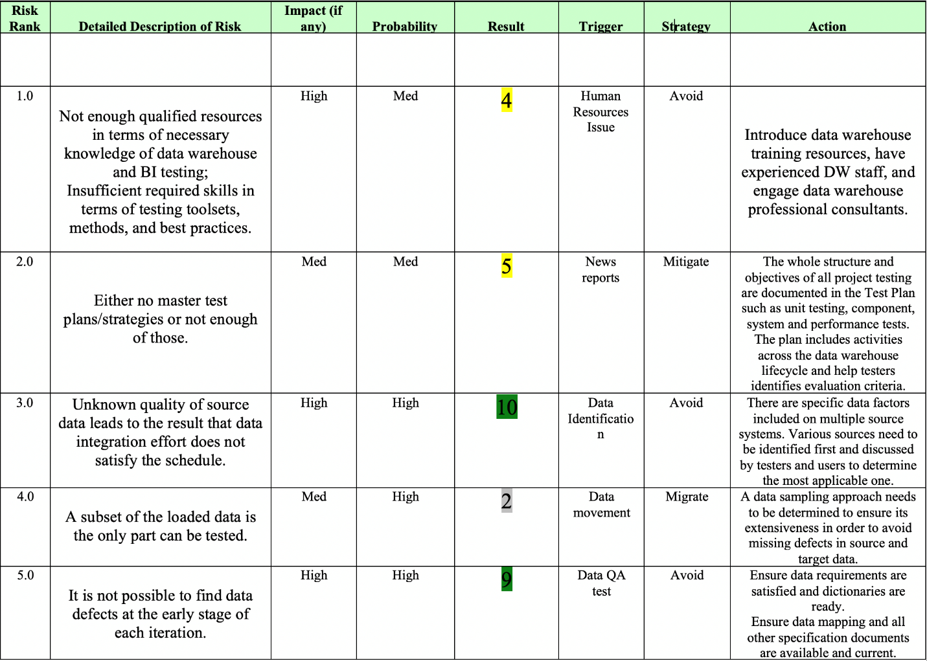

Threats

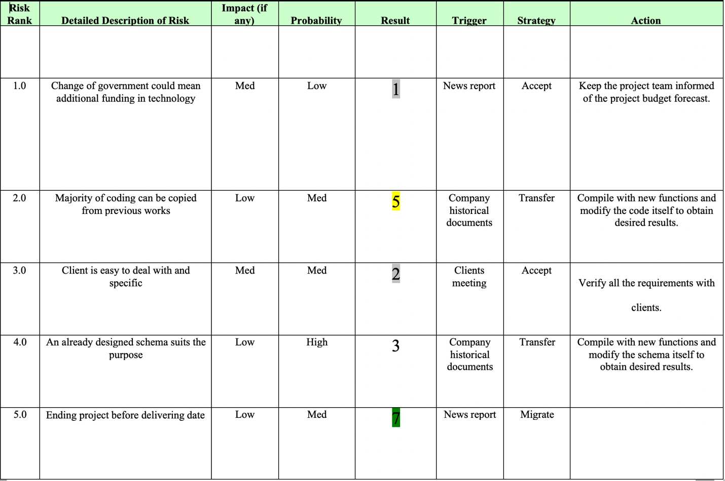

Opportunities

# group lessons learned

We worked as a team and discussed about work breakdown structures. As a team it worked out because they were many ideas and many learning things which helped to create and complete the project successfully. We have a very good group where everyone actively participated and helped the problem to get solved and we also shared a very good knowledge among us which would be helpful for us in future.

Understanding the goals and objectives of the project can help us to create the project successfully. To prevent such problems in the project everyone should analyze the project, discuss about the project, giving ideas for the project and working hard to complete the project successfully.

# References

Chapman, C. B., & Ward, S. C. (2011). *How to manage project opportunity and risk: why uncertainty management can be a much better approach than risk management*. Chichester, UK: Wiley.

Golfarelli, M., & Rizzi, S. (2009). *Data warehouse design: modern principles and methodologies*. New York: McGraw-Hill.

INSTITUTE, P. R. O. J. E. C. T. M. A. N. A. G. E. M. E. N. T. (2018). *Guide to the project management body of knowledge*. s.l.: Project management inst.

Portny, S. E. (2017). *Project management*. Hoboken, NJ: for dummies, a Wiley brand.